
KENYA CERTIFICATE OF BASIC EDUCATION

SENIOR SCHOOL ASSESSMENT

TERM 2: FIRST ASSESSMENT 2026
GRADE 10 – INFORMATION COMMUNICATION TECHNOLOGY
Time: 2 Hours
LEARNER’S DETAILS
Name: _____________________________________________________________. School: ____________________________________________.
Assessment Number: _______________________________________________. Date: ____________________________________________.
School Code: ______________________________________________________. Signature: _______________________________________.

INSTRUCTIONS TO CANDIDATES
- Write your name in the spaces provided above.
- Write the name of your school and your stream in the spaces provided.
- Write your admission number and the date of the assessment in the spaces provided.
- This paper consists of two sections: A and B.
- Answer all questions in section A and section B.
- Answer the questions in English.
- All answers MUST be written in the spaces provided in the paper.
- Do NOT remove any page from this question paper.

LEARNER’S SCORE
SCORES | TOTAL | LEARNER SCORE
SECTION A | 30
SECTION B | 50

SECTION A: (30 marks)
Answer ALL questions in this section.
- Grade 10 learners at Moi Girls Senior School were taught about Information and Communication Technology (ICT). What is ICT? (1 mark)
_______________________________________________________________________________________________________________________________________
______________________________________________________________________________________________________________________________________
- ICT infrastructure is made up of several components. Name any two of them. (2 marks)
- _______________________________________________________________________.
- _______________________________________________________________________.

- Excessive use of digital devices is a major concern.

Suggest ways of controlling this. (2 marks)
- _________________________________________________________________________________________________________________________.
- ________________________________________________________________________________________________________________________.


- The diagram below shows the sitting posture of two learners in a computer lab:

Linet Kelvin
Which learner is seated correctly? Explain your answer. (2 marks)
Learner | Reason for your answer

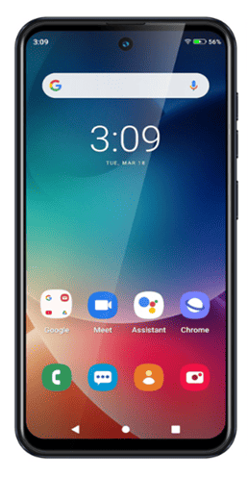

- Brianne uses various ICT tools for communication purposes. Identify these tools. (4 marks)

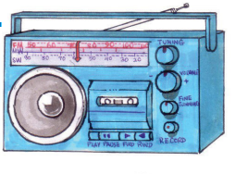

a) _____________________ b) ___________________________ c) _______________________ d) _________________________
- During the April Holiday Teachers at Kapsabet Senior School want to conduct an online training session. Which video conferencing tool would you recommend? (1 mark)
_________________________________________________________________________________________________________.
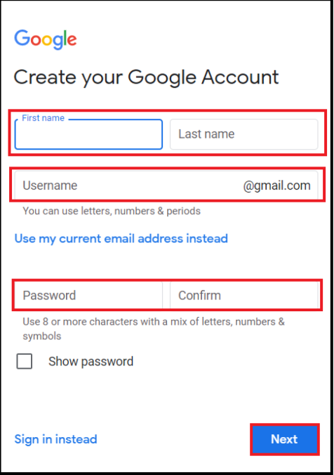
- Nyambura of Lodwar Senior School created a Gmail account as shown below,

What is the use of Gmail in communication? (1 mark)
_____________________________________________________________________________________________________________________________________
- (a) Kelvin states that technology in communication supports global connectivity. Explain how this happens. (2 marks)
_____________________________________________________________________________________________________________________________________________________________________________________________________________________________________________________________________________________________________________________________________________________________________________________________________________________
- ICT is applied in various areas in society. Explain two ways ICT is used in education and learning. (2 marks)
- _______________________________________________________________________.
- _______________________________________________________________________.

- Japheth posts some of his class videos in the following platform.


Name the following social media platform: _______________________________________________________ (1 mark)
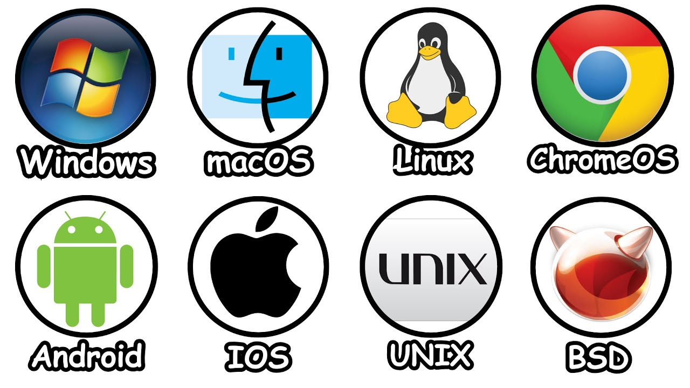
- Learners at Kericho Senior School use devices with different operating systems. Name the operating systems shown below. (3 marks)
a) _______________________ b) _______________________ c) _______________________
- Identify the following operating system interfaces based on the descriptions given: (3 marks)
Part | Description | Operating System Interface
a) | Users interact directly with the screen using touch gestures. | _____________________________
b) | Users select options from a list or menu. | _____________________________
c) | Users interact through physical gestures detected by sensors or cameras. | _____________________________
- Otieno wants to back up files on his computer.
a) Which software should he use? (1 mark)
_______________________________________________________________________________________________________________
b) Why is it important to back up files on a computer? (1 marks)
- ___________________________________________________________________________________________________________________________.
- __________________________________________________________________________________________________________________________.
- Citizenship refers to the official recognition of a person as a member of a country. Who is a digital citizen? (2 marks)
____________________________________________________________________________________________________________________________________________________________________________________________________________________________________________________________.

SECTION B (50 MARKS)
Answer all questions in the spaces provided.
- Safe use of ICT protects users.
a) Outline three healthy practices when using ICT devices. (3 marks)
- ______________________________________________________________________________________________________________________________
- ______________________________________________________________________________________________________________________________
- ______________________________________________________________________________________________________________________________
b) State four safety concerns related to ICT. (4 marks)
- ______________________________________________________________________________________________________________________________
- ______________________________________________________________________________________________________________________________
- ______________________________________________________________________________________________________________________________
- ______________________________________________________________________________________________________________________________
c) List three importance of safe ICT use. (3 marks)
- ______________________________________________________________________________________________________________________________
- ______________________________________________________________________________________________________________________________
- ______________________________________________________________________________________________________________________________
- Naomi enjoys ICT lessons. Explain five benefits of ICT as a learning area. (10 marks)
- ______________________________________________________________________________________________________________________________
- ______________________________________________________________________________________________________________________________
- ______________________________________________________________________________________________________________________________
- ______________________________________________________________________________________________________________________________
- ______________________________________________________________________________________________________________________________
- Modern communication relies on digital technologies.
a) Explain three technologies used in communication. (6 marks)
- ______________________________________________________________________________________________________________________________
- ______________________________________________________________________________________________________________________________
- ______________________________________________________________________________________________________________________________
b) State four importance of technology in communication. (4 marks)
- ______________________________________________________________________________________________________________________________
- ______________________________________________________________________________________________________________________________
- ______________________________________________________________________________________________________________________________
- ______________________________________________________________________________________________________________________________
- ICT has influenced many sectors. Explain how ICT is used in: (10 marks)
a) Banking
______________________________________________________________________________________________________________________________________________________________________________________________________________________________________________________________________________
b) Security
_______________________________________________________________________________________________________________________________________
_______________________________________________________________________________________________________________________________________
c) Entertainment
_______________________________________________________________________________________________________________________________________
_______________________________________________________________________________________________________________________________________
d) Education
_______________________________________________________________________________________________________________________________________
_______________________________________________________________________________________________________________________________________
e) Health
_______________________________________________________________________________________________________________________________________
_______________________________________________________________________________________________________________________________________

- During a lesson, learners discussed operating systems. Learners gave examples of devices
Devices that uses O.S
- Desktop computer
- Laptop
- Smartphone
- Tablet
- Smart TV

a) Identify a device that uses the following operating systems:
 | Operating System | Device (Choose from the list below)
i. | Windows | ___________________________________
ii. | Android | ___________________________________
b) State two functions of an operating system. (2 marks)
- ______________________________________________________________________________________________________________________________
- ______________________________________________________________________________________________________________________________
c) What is the difference between copying and moving files? (2 marks)

Copying files | Moving files
d) Describe the process of rebooting a computer and give one advantage. (4 marks)
- ______________________________________________________________________________________________________________________________
- ______________________________________________________________________________________________________________________________
- ______________________________________________________________________________________________________________________________
- ______________________________________________________________________________________________________________________________

THIS IS THE LAST PRINTED PAGE

MARKING SCHEME – GRADE 10 INFORMATION COMMUNICATION TECHNOLOGY

SECTION A (30 MARKS)

1. Definition of ICT (1 mark)
I. ICT (Information and Communication Technology) is the use of computers, digital devices, and communication tools to store, retrieve, transmit, and manipulate information.
II. Alternative phrasing:
- Technology used to communicate and process information electronically.
- Integration of computing and communication technologies for information management.

2. ICT Infrastructure Components (2 marks)
I. Hardware (computers, servers, routers, switches, printers)
II. Software (application software, system software, productivity tools)
Other acceptable components:
- Networking components (cables, Wi-Fi routers)
- Storage devices (external drives, cloud storage)
- Communication devices (phones, modems)

3. Ways of Controlling Excessive Digital Device Use (2 marks)
I. Limiting screen time or using timers.
II. Taking regular breaks / following the 20-20-20 rule (look at something 20 feet away for 20 seconds every 20 minutes).
Other valid answers:
- Encouraging physical exercise and outdoor activities.
- Using parental or self-control apps to monitor usage.
- Prioritizing essential tasks before leisure device use.

4. Correct Sitting Posture in a Computer Lab (2 marks)
- Correct learner: Kelvin
- Reason
I. Feet flat on the floor, back straight, elbows at 90°, screen at eye level.
II. Reduces strain on eyes, neck, and back.
Other points:
- Avoid slouching or leaning forward excessively.
- Chair and desk at appropriate height.

5. ICT Tools for Communication (4 marks)
I. Radio
II. Smart phone
III. laptop
IV. projector

6. Recommended Video Conferencing Tool (1 mark)
I. Zoom
II. Microsoft Teams
III. Google Meet
IV. Skype

7. Use of Gmail in Communication (1 mark)
I. Sending and receiving electronic messages.
II. Alternative phrasing:
- Sharing files, documents, or information electronically.
- Professional and personal communication online.

8. How Technology Supports Global Connectivity (2 marks)
I. Allows instant communication across countries using emails, video calls, and social media.
II. Facilitates sharing of information, collaboration, and online learning worldwide.
Other points:
- Access to global news and events.
- Enables international trade, business, and remote work.

9. ICT Applications in Education and Learning (2 marks)
I. E-learning platforms for online courses and tutorials.
II. Research and access to digital educational resources.
Other points:
- Use of simulations, animations, and virtual labs.
- Communication with teachers and peers via emails and learning management systems.

10. Social Media Platform (1 mark)
I. TikTok

11. Operating Systems (3 marks)
I. Android
II. Windows
III. iOS

12. Operating System Interfaces (3 marks)
I. Touch interface – interaction via touch gestures.
II. Menu-driven interface – select options from menus.
III. Gesture-based interface – using sensors or cameras to detect movement.
Other alternatives:
- Graphical User Interface (GUI) for touch or visual interaction.
- Command-line interface (CLI) if described.

13a. Software for Backing Up Files (1 mark)
I. Backup software / File backup utility / Cloud storage services (Google Drive, OneDrive, Dropbox).

13b. Importance of Backing Up Files (1 mark)
I. Prevents loss of important data due to accidental deletion, corruption, or hardware failure.
II. Ensures data recovery in case of malware or system crashes.

14. Digital Citizen (2 marks)
I. A person who uses digital technologies responsibly, safely, and ethically.
II. Alternative phrasing:
- Someone who respects laws, privacy, and digital etiquette online.
- Participates positively in the digital community.

SECTION B (50 MARKS)

15a. Healthy Practices When Using ICT Devices (3 marks)
I. Maintaining proper posture while using devices.
II. Taking regular breaks to prevent eye strain.
III. Ensuring proper lighting and ergonomics while working.
Other points:
- Using anti-glare screens.
- Adjusting screen brightness and distance.

15b. Safety Concerns Related to ICT (4 marks)
I. Cyberbullying or online harassment.
II. Identity theft / online scams.
III. Exposure to inappropriate content.
IV. Eye strain, repetitive strain injuries, or poor posture.
Other points:
- Hacking and malware infections.
- Privacy breaches or data leaks.

15c. Importance of Safe ICT Use (3 marks)
I. Protects personal data and privacy.
II. Prevents physical harm from prolonged device use.
III. Ensures ethical and responsible online behavior.
Other points:
- Avoids legal issues and cybercrimes.
- Promotes mental well-being and reduces addiction.

16. Benefits of ICT as a Learning Area (5 marks)
I. Enhances access to educational resources and research materials.
II. Supports e-learning and online collaboration.
III. Encourages development of digital skills.
IV. Improves communication between teachers and learners.
V. Enables multimedia learning for better understanding.
Other points:
- Facilitates creativity and problem-solving.
- Prepares learners for ICT-dependent job markets.

17a. Technologies Used in Communication (3 marks)
I. Internet / Email / Social Media
II. Mobile Phones / Messaging Apps
III. Video Conferencing / VoIP

17b. Importance of Technology in Communication (4 marks)
I. Enables instant communication globally.
II. Reduces communication costs.
III. Facilitates business, learning, and collaboration.
IV. Supports information sharing and social networking.

18. ICT Applications in Sectors (10 marks)
a) Banking
I. Online banking, mobile banking, and ATM services.
II. Digital transactions, e-payments, and money transfers.
III. Record keeping and automated financial management.
b) Security
I. CCTV monitoring and surveillance systems.
II. Biometric access control (fingerprints, facial recognition).
III. Alarm and alert systems for physical and digital security.
c) Entertainment
I. Online streaming platforms (Netflix, YouTube).
II. Digital gaming and virtual reality.
III. Music, video, and digital content distribution.
d) Education
I. E-learning platforms and virtual classrooms.
II. Digital libraries, simulations, and interactive learning tools.
III. Online assessments and student management systems.
e) Health
I. Telemedicine and online consultations.
II. Health information systems and patient record management.
III. Digital diagnostics and wearable health monitoring devices.

19a. Devices Using Operating Systems
I. Windows – Desktop computer / Laptop
II. Android – Smartphone / Tablet

19b. Functions of an Operating System (2 marks)
I. Manages computer hardware and software resources.
II. Provides user interface and facilitates interaction with the computer.
Other points:
- Manages memory, storage, and processes.
- Handles file and device management.

19c. Difference Between Copying and Moving Files (2 marks)
Copying Files | Moving Files
Creates a duplicate of the file in a new location. | Transfers the file to a new location, removing it from the original.
Original file remains in the source location. | Original file is no longer in the source location.

19d. Rebooting a Computer (4 marks)
I. Rebooting involves restarting the computer to refresh system processes.
II. Can be done via the restart option in the operating system.
III. Resolves software or hardware issues and refreshes memory.
IV. Advantage: Restores system stability and clears temporary errors.

